# Calculate the Contribution of Each Stock to the Index

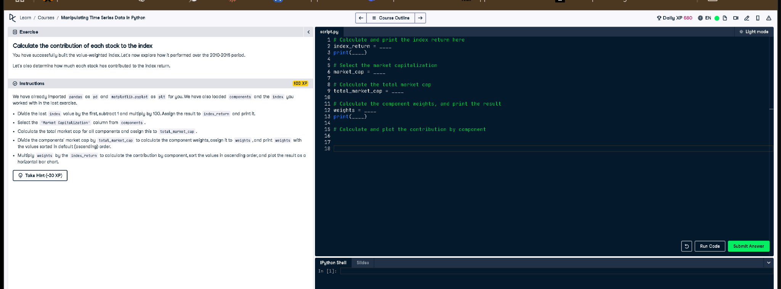

## Corrected Code Answer

# Calculate and print the index return here  
index_return = (index[-1] / index[0] - 1) * 100  
print(index_return)  
  
# Select the market capitalization  
market_cap = components['Market Capitalization']  
  
# Calculate the total market cap  
total_market_cap = market_cap.sum()  
  
# Calculate the component weights, and print the result  
weights = market_cap / total_market_cap  
print(weights.sort_values())  
  
# Calculate and plot the contribution by component  
contributions = weights.mul(index_return)  
contributions.sort_values().plot(kind='barh', title='Index Contribution by Component')  
plt.show()

## Explanation

This script calculates how much each stock contributed to the index's growth. The return is calculated from the first and last index values. Market cap weights are calculated, and then multiplied using `.mul()` by the index return to find the contribution of each stock. Finally, the contributions are visualized in a horizontal bar chart.